**RAJSHAHI UNIVERSITY OF ENGINEERING AND TECHNOLOGY**

**LAB FINAL REPORT**

COURSE NAME: SESSIONAL BASED ON CSE 2103

COURSE CODE: CSE 2104

**SUBMITTED TO-**

**Prof. Dr. Boshir Ahmed**

Professor

Department of Computer Science & Engineering

Rajshahi University of Engineering & Technology

**Md. Zahirul Islam**

Lecturer

Department of Computer Science & Engineering

Rajshahi University of Engineering & Technology

**SUBMITTED BY-**

Srabonti Deb

Roll-1803163

Section - C

Department of Computer Science & Engineering

SUBMISSION DATE -25 AUGUST,2021

**1) Experiment Name:** F = POS (2, 6, 8, 9, 10, 12, 14)

**Objectives:**

* To learn about Boolean algebra.
* To understand what are combinational logic circuits.
* To learn about canonical & standard form.
* To learn about using the product-of-sums method to design a logic circuit based on a design truth table.
* To learn about how to simplify Boolean expression.
* To learn about maxterm & minterm & how to findout these.

**Theory:** Digital circuit operates using digital signals.These signals have discrete binary values: zero and one.Zero signifies the false state while one signifies the true state.Boolean algebra is a type of algebra that helps to represent binary numbers and binary variables. Canonical form is a method of representing Boolean functions of Boolean algebra while standard form is a simplified version of canonical form.

Minterm: A product term in which all the variables appear exactly once, either complemented or uncomplemented.Denoted by $m_{j}$,where j is the decimal equivalent of the minterm’s corresponding binary combination ($b_{j}$).

Maxterm: A sum term in which all the variables appear exactly once, either complemented or

Uncomplemented.Denoted by $M_{j}$,where j is the decimal equivalent of the maxterm’s corresponding binary combination ($b_{j}$).

**Experimental Analysis:**

* **Circuit Diagram:**

**1.1- (Drag & drop) F = POS (2, 6, 8, 9, 10, 12, 14):**

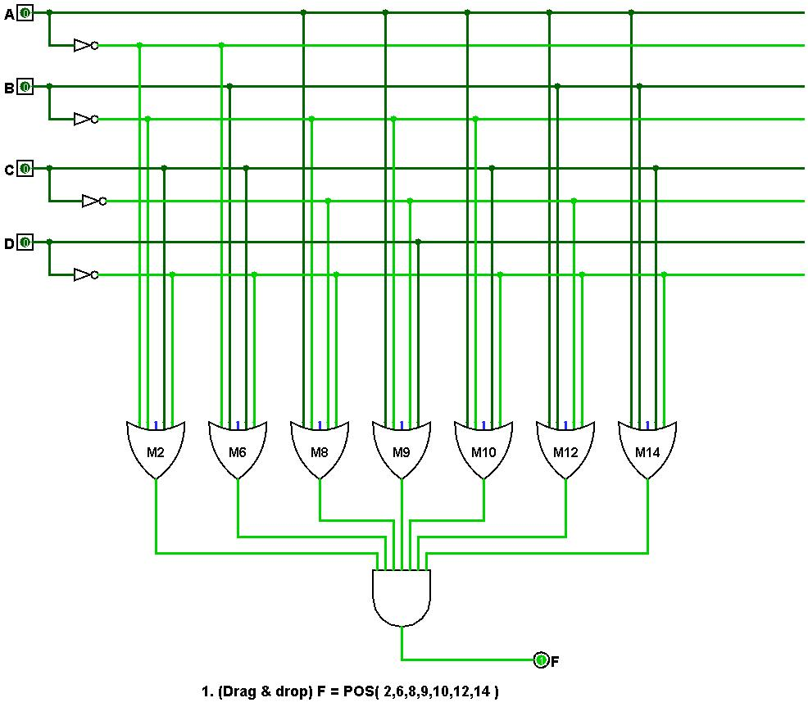

**1.2- (Analyse Circuit) F = POS (2, 6, 8, 9, 10, 12, 14):**

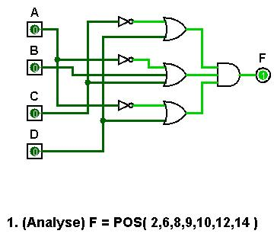

* **Truth Table:**

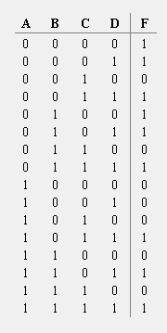

**Conclusion:** In this experiment,we discussed about canonical form (Product of sums-POS) ,it’s characteristics and diagram.

**2) Experiment Name:** Simplified version of F.

**Objectives:**

* To learn about how to simplify Boolean expression.
* To learn about karnaugh map.

**Theory:** In Boolean algebra simplification, a Boolean expression is translated to another form with less number of terms and operations. We use karnaugh map to simplify Boolean algebra.

**Karnaugh map simplification:**

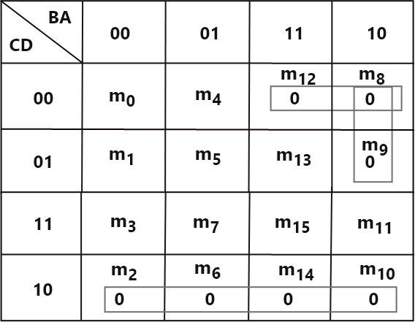

From Karnaugh map solution we get:

**F =($\overline{A}+B+C$)($\overline{A}+D)$ ($\overline{C}$ + $D$)**

**Experimental Analysis:**

* **Circuit Diagram:**

**2- Simplified Version of F:**

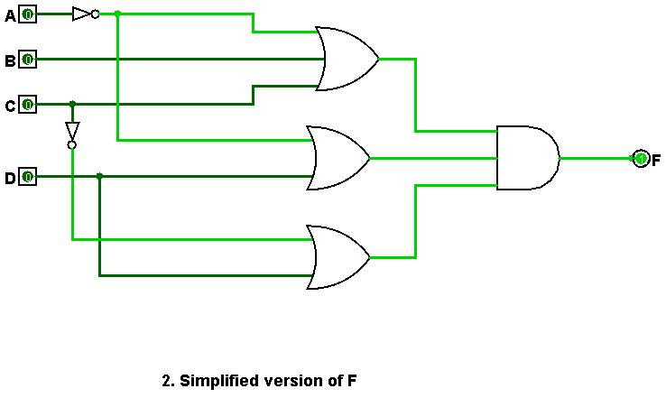

* **Truth Table:**



**Conclusion:** We can say that the result of simplified version of F in 1 is verified.

**3) Experiment Name:** Design a counter that counts 1, 5, 3, 2, 4, 1 by using T flip-flops.

**Objectives:**

* To know the characteristics of a Counter
* To know how to draw a Counter by using T Flip-Flops.
* To generate the truth table of Counter by using T Flip-Flops.
* To verify the output of Counter.

**Theory:** A [**C**ounter](https://en.wikipedia.org/wiki/Counter_(digital)) is a device which stores the number of times a particular event or process has occurred, often in relationship to a clock signal. Counters are used in digital electronics for counting purpose, they can count specific event happening in the circuit.

A flip flop is an electronic circuit with two stable states that can be used to store binary data. A T flip-flop is like a JK flip-flop. These are basically a single input version of JK flip-flops. This modified form of JK flip-flop is obtained by connecting both inputs J and K together. It has only one input along with the clock input.

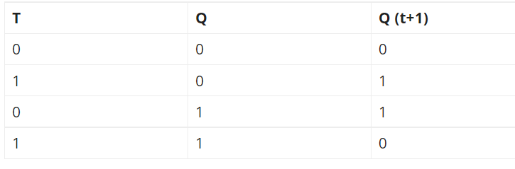

For the problem we get from karnaugh map:

**TC:**

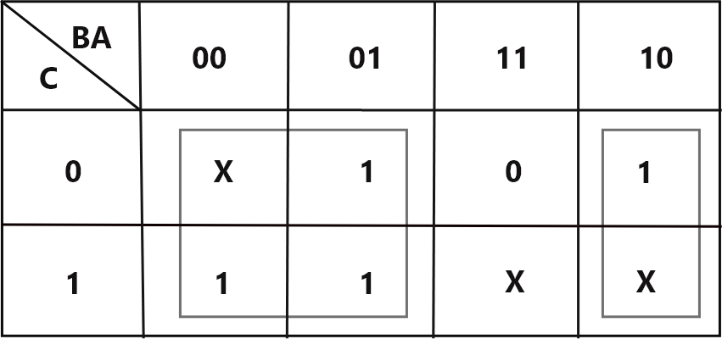

**TB:**

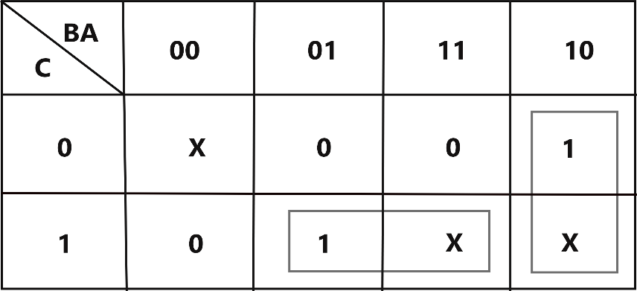

**TA:**

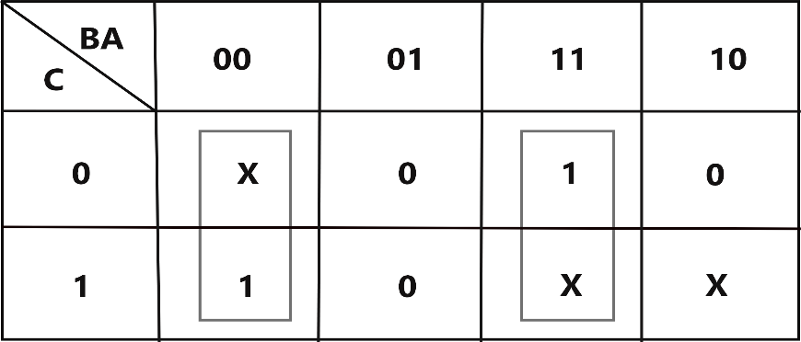

From kmap solution we get-

TA: + AB

TB: CA + B $\overline{A}$

TC: +

**Experimental Analysis:**

* **Circuit Diagram:**

**State transition diagram:**

**3- Design a counter that counts 1, 5, 3, 2, 4, 1 by using T flip-flops:**

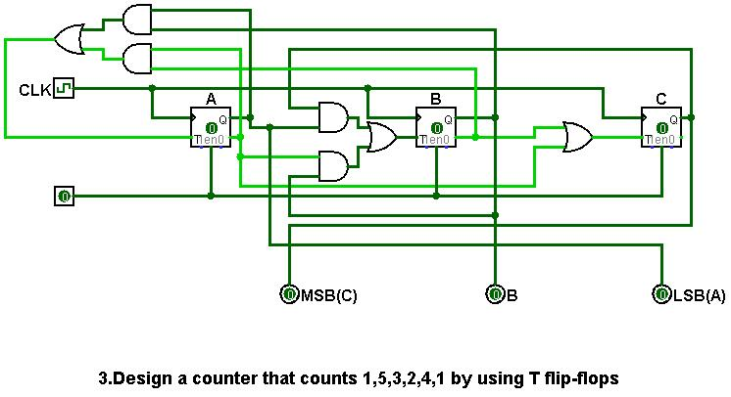

* **Circuit Excitation Table:**

|  |  |  |  |  |  |  |  |  |
| --- | --- | --- | --- | --- | --- | --- | --- | --- |
| **QT** | | | **QT+1** | | | **TC** | **T­B** | **TA** |
| 0 | 0 | 1 | 1 | 0 | 1 | 1 | 0 | 0 |
| 1 | 0 | 1 | 0 | 1 | 1 | 1 | 1 | 0 |
| 0 | 1 | 1 | 0 | 1 | 0 | 0 | 0 | 1 |
| 0 | 1 | 0 | 1 | 0 | 0 | 1 | 1 | 0 |
| 1 | 0 | 0 | 0 | 0 | 1 | 1 | 0 | 1 |

**Conclusion:** In this experiment,we discussed about a Counter by using T Flip-Flops.